Instructions for Downloading & Installing Astrometrica

1. Go to the IASC website, http://iasc.hsutx.edu, and click on Astrometrica.

2. Once on the Astrometrica page, right click on Astrometrica Setup and download to the Desktop.

3. From the Desktop, double click on AstrometricaSetup.exe. Click on Run.

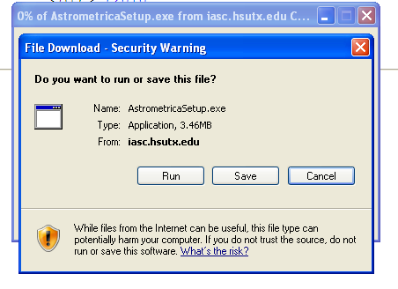

4. Follow the onscreen instructions to install Astrometrica. When completed, click on Finish.

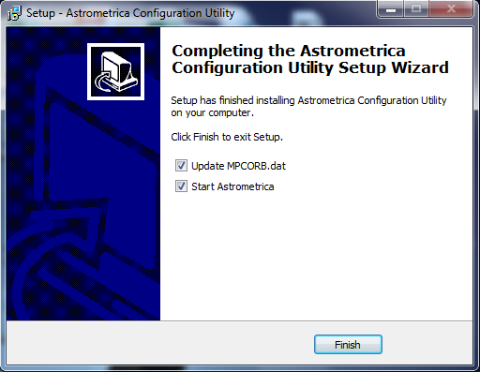

5. The following screen will pop up. This will take several minutes to complete as it updates the Minor Planet Center (MPC) database.

Important: This update will be performed each time you start Astrometrica.

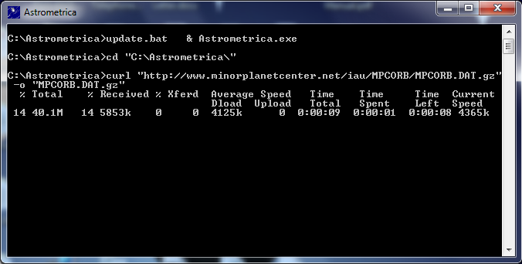

6. Click on Yes to clear the MPC report.

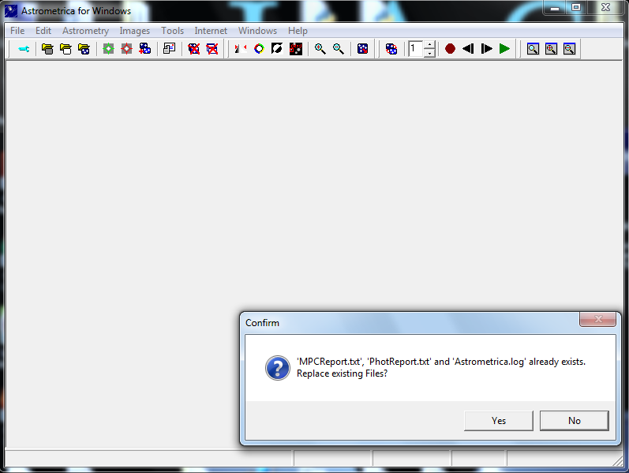

7. You must register Astrometrica, for free unlimited use. Click on Help. Click on Registration, then type in the License and Key.

The License and Key is provided by email only to citizen science groups participating in an asteroid search campaign. However, you can still use Astrometrica on a limited basis for 100 days without the License and Key.
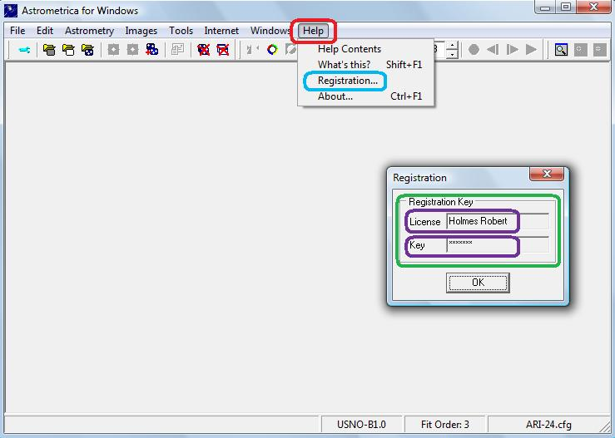

8. Astrometrica is downloaded and ready to use.

    - To learn how to use Astrometrica, review “Instructions For Using Astrometrica.”
    - To learn how to distinguish between true and false moving targets review “Signature Guide.”

9. For the success of your citizen science group in an IASC Asteroid Search Campaign, it is important that you as their leader can do the following:

a. Run Astrometrica in the manual mode.
b. Distinguish between a true and false moving target.
c. Prepare a clean and accurate MPC report.

If you need help installing or using Astrometrica, contact either:

- Ginger Anderson
profgingie@gmail.com
- Denise Rothrock
dcr9760@gmail.com
- Joshi Yogeshkumar Dileepkumar
1729joshi@gmail.com
- Silvana Copceski
scopceski123@gmail.com
- Pat Donahue
donahuep@verizon.net

Dr. Patrick Miller, IASC Director at Hardin-Simmons University, is available at the IASC email address: iascsearch@hsutx.edu.

The International Astronomical Search Collaboration welcomes you!!

